

NATIONAL UNIVERSITY OF TECHNOLOGY
(Department of Computer Science)
CS161– Database Systems
Instructor: Noushin Saba
Name: Bisma Fatima
Roll no: f24605036

LAB TASK 05

INLAB TASK
TASK 01

• Insert the following order details records into orderdetails collection.
- "Order ID": 10572, "Product": 16, "Unit Price": "$17.45", "Quantity": 12, "Discount": "10.00%"
- "Order ID": 10572, "Product": 32, "Unit Price": "$32.00", "Quantity": 10, "Discount": "10.00%"
- "Order ID": 10572, "Product": 40, "Unit Price": "$18.40", "Quantity": 50, "Discount": "0.00%"
- "Order ID": 10572, "Product": 75, "Unit Price": "$7.75", "Quantity": 15, "Discount": "10.00%"
- "Order ID": 10626, "Product": 53, "Unit Price": "$32.80", "Quantity": 12, "Discount": "0.00%"
- "Order ID": 10626, "Product": 60, "Unit Price": "$34.00", "Quantity": 20, "Discount": "0.00%"
- "Order ID": 10626, "Product": 71, "Unit Price": "$21.50", "Quantity": 20, "Discount": "0.00%"
- "Order ID": 10654, "Product": 4, "Unit Price": "$22.00", "Quantity": 12, "Discount": "10.00%"
- "Order ID": 10672, "Product": 38, "Unit Price": "$263.50", "Quantity": 15, "Discount": "10.00%"
- "Order ID": 10672, "Product": 71, "Unit Price": "$21.50", "Quantity": 12, "Discount": "0.00%"

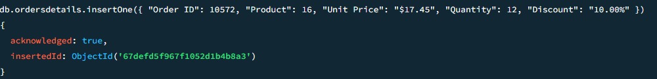
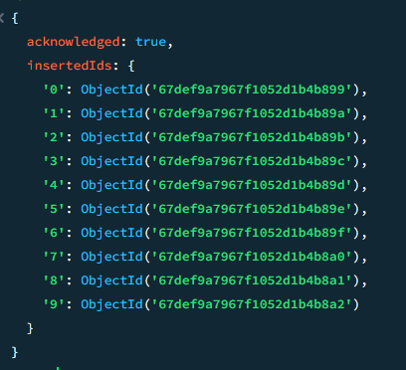

• Retrieve only Product and Quantity fields for all orders (excluding_id).

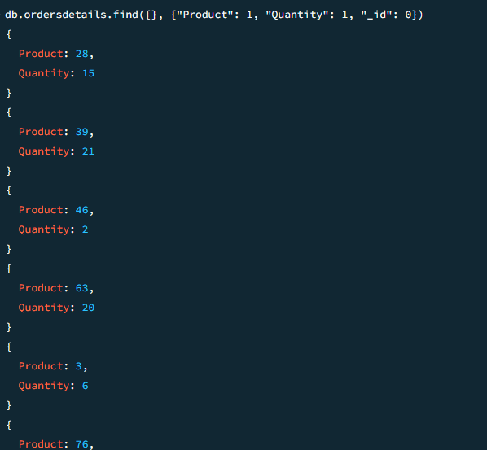

• Get orders where the discount is greater than 0% sorted in ascending order.

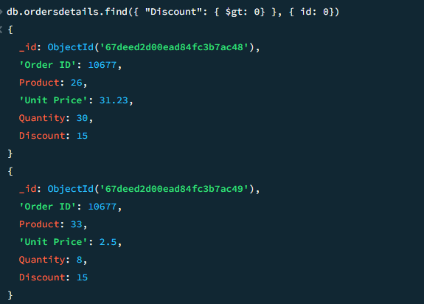

TASK 02
• Update a customer's phone number to “35.60.84.10where CustomerID is “LACOR”.

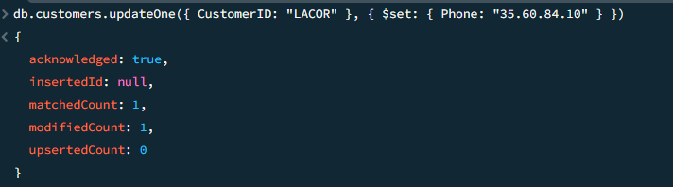

• Delete customers records with country “Brazil”.

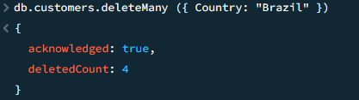

• Retrieve all products under the category Confections form the products collection.

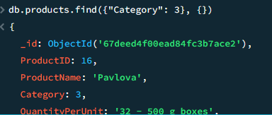

• Using the orderdetails collection Retrieve all orders with the product “Tofu”.

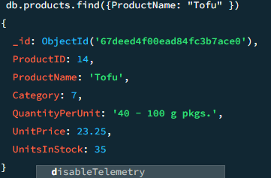

post-Lab Task
TASK 01

• List all orders that were shipped after '01-Jan-1996'.

• Find all orders handled by employee ID 1.

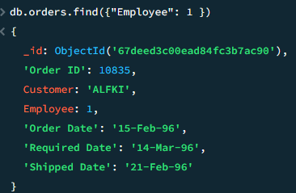

• Retrieve orders where the ‘Required Date’ is greater than ‘01-May-96’.

